88993

  - Save selected e-mail(s) to your Documents folder as PDF; Browse Documents folder

Save E-MAIL(S) AS PDF(S)

Author:
Michael D. Newby
www.recursivecreativity.com
www.excelusersgroup.org
(not active)

Last Updated:

March 7, 2021

Table of Contents
Prerequisites 4
Add Developer Tab to Ribbon 5
Import VBA (modules) File(s) 6
Add Reference to Microsoft Word Object Library 8
Add Code (macros) to QAT (Quick Access Toolbar) 9
Customize QAT Icons Added 11
Usage 12

Each heading below is link back to this page, the Table of Contents (TOC).

Prerequisites

There are several prerequisites to enable saving e-mail(s) to your Documents folder as PDF file.

- Developer tab must be visible in Outlook Ribbon
- VBA Project file(s) need to be imported into Outlook VBE:
  - modSaveEmailAsPDF.bas (required)
  - modOpenDocuments.bas (optional)
- Reference to Microsoft Word must be made in Outlook VBE (Visual Basic Editor)

Add Developer Tab to Ribbon

In Outlook Ribbon,

- click File
- click Options
- Click on Customize Ribbon

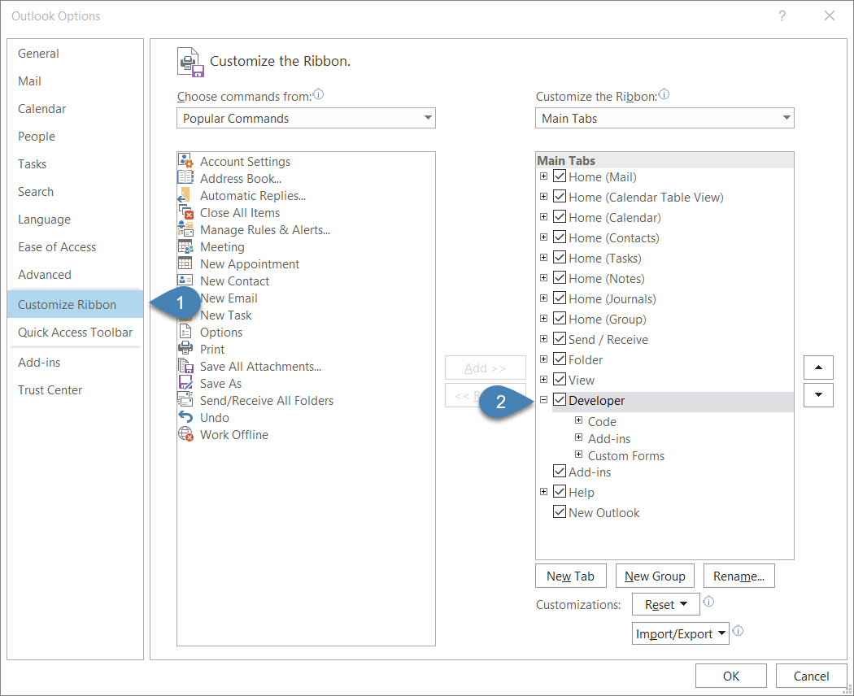

- Click checkbox for Developer
- Click OK

The Outlook Developer tab should now be visible:
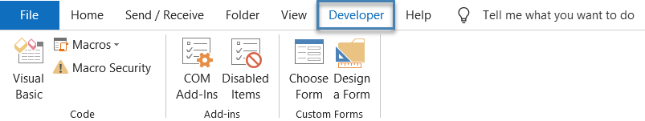

Import VBA (modules) File(s)

- Open the following file

- Save file(s) to your Desktop or Documents folder (somewhere convenient)
- Close above file

On Outlook Developer tab,

- Click on Visual Basic to open the VBE (Visual Basic Editor)
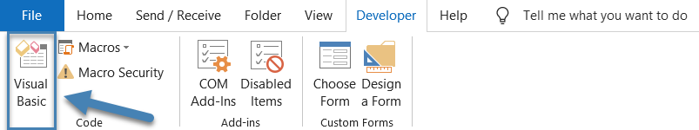

- Right-click on Project1
- Select Import File…
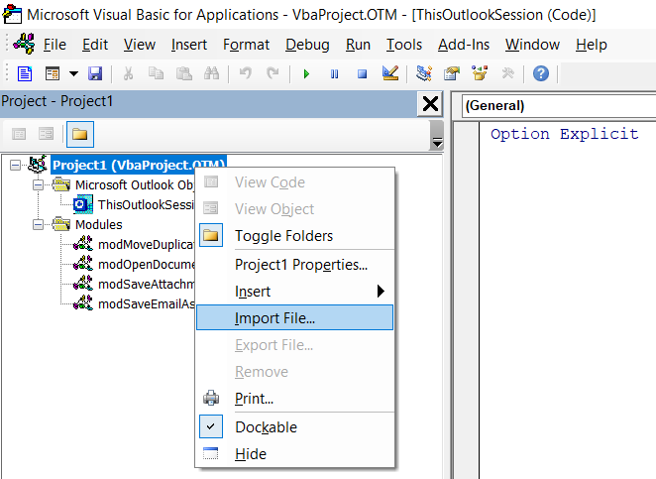
- Navigate to where you save the files in step 7 above and double click on:

modSaveEmailAsPDF.bas

This file contains code that will save the selected e-mail(s) to separate PDF files.

- Repeat steps 11 and 12 to import the second optional file:

modOpenFolder.bas

This file contains code to open your Documents folder. I chose this folder as default as opposed to provide option for browsing to folder…it is simpler!

You should now see two modules that bear the name of the files in steps 12 and 13 above…

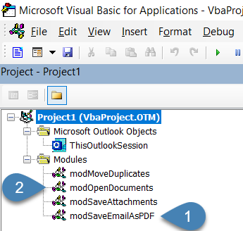

- Close the VBE (Visual Basic Editor)

Add Reference to Microsoft Word Object Library

- In VBE, click on Tools
- Click on References
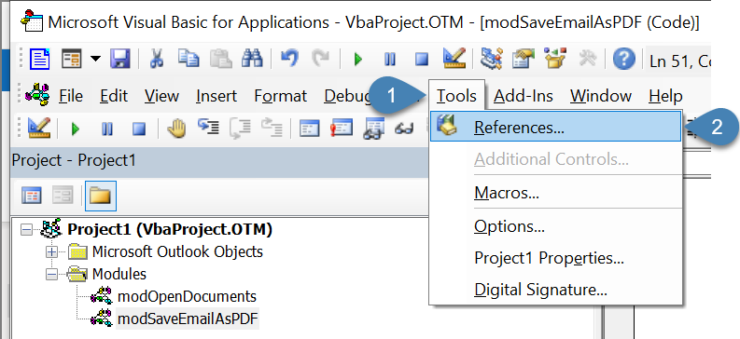

- Scroll down to find Microsoft Word 16.0 Object Library and add checkmark to checkbox
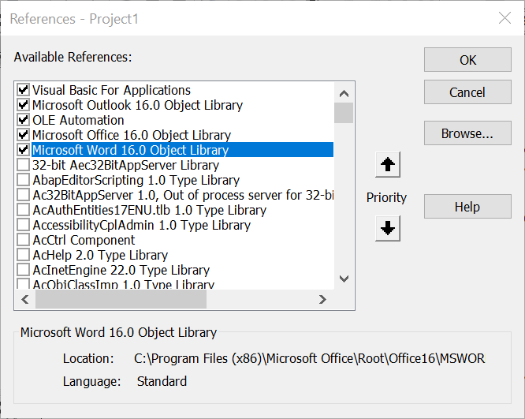

Please note that if you have different version of Microsoft Office installed, Word 16.0 will not be your option…choose one or more that appear in this list.

- Click OK

Add Code (macros) to QAT (Quick Access Toolbar)

- Click on File in Outlook Ribbon
- Click on Options
- Click on Quick Access Toolbar

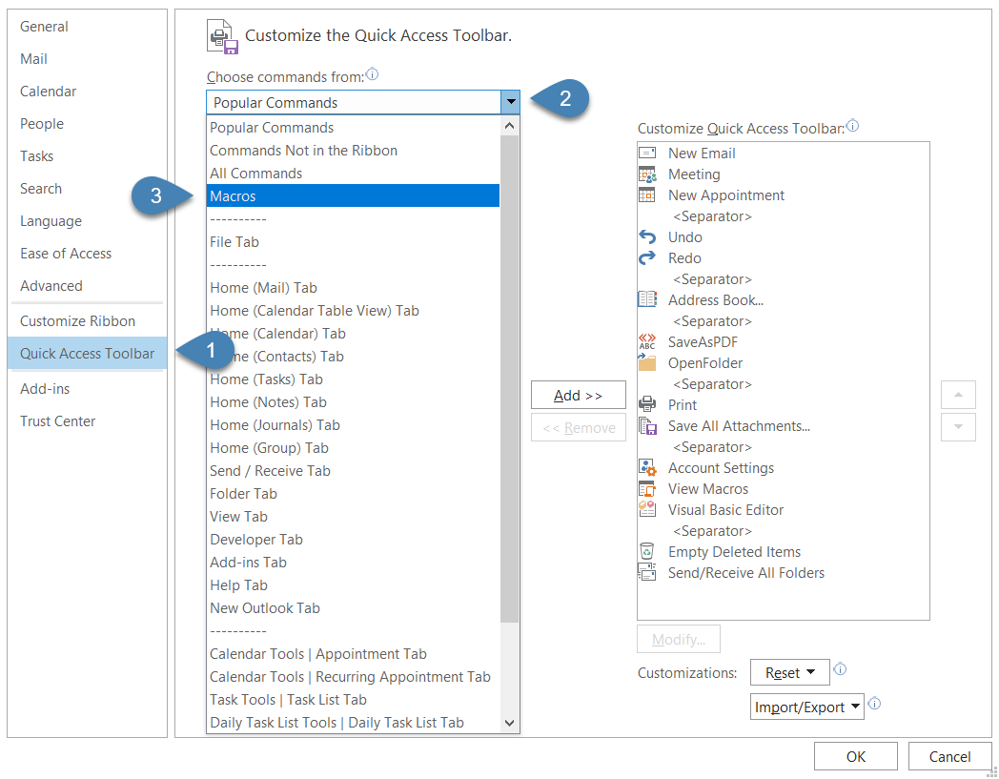
- Click on arrow next to popular commands to display drop-down list options
- Choose Macros
- The two macros previously imported in steps 12 through 14 above should now be displayed

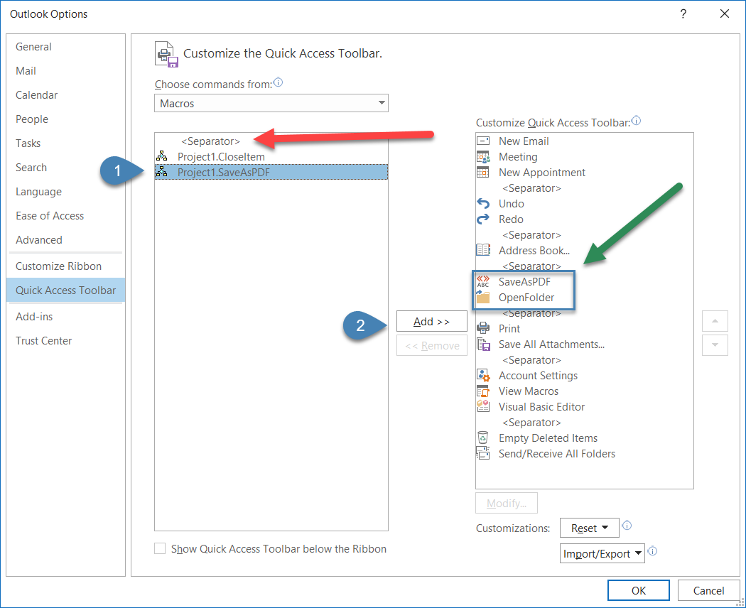

- Select a macro
- Click on Add >>
- Repeat steps 22 and 23 for the second file

Steps 22 through 242 above will add the two macros to the QAT. However, please note that I have already modified and reordered mine as pointed to by green arrow.

Please note you would have seen other modules in the VBE above that are not displayed here. I make most of my VBA subroutines Private so they are not displayed when users get nosy and go where they shouldn’t and try things they shouldn’t. After I add the items to my QAT I go back and make the code Private. For the average user this is not necessary.

The red arrow is pointing at the separator which I use to logically separator icons for my preferences. If you look to Customize Quick Access Toolbar list on the right, you will see numerous separators. You can double up if you prefer to separate your groups more.

Customize QAT Icons Added

- Click on macro in Customize Quick Access Toolbar list (1)
- Click on Modify… button (2)
- Rename to shorten display name (3)
- Select Symbol (icon) to be displayed in QAT (4)
- Click OK

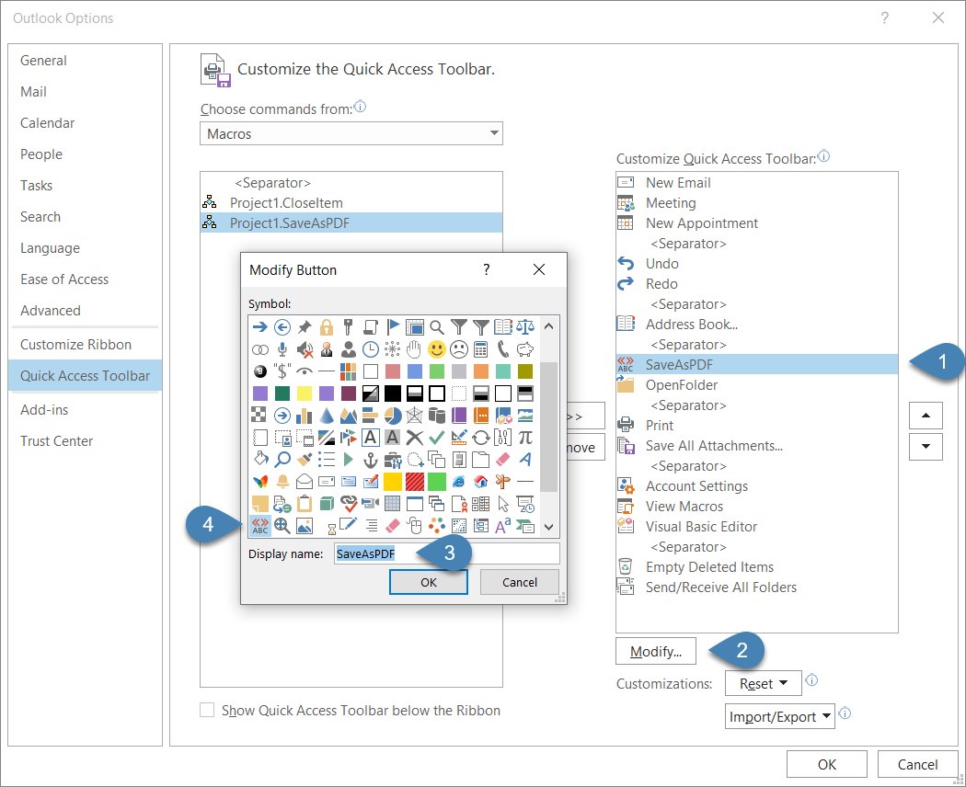

- Repeat steps 25 through 29 for second macro
- Reorder and add separators according to your tastes
- Click OK

The two items added to the QAT should now be visible:
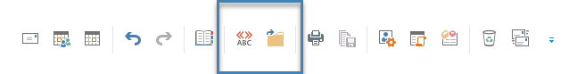

Usage

- Select one or more e-mails
- Click on SaveAsPDF icon in QAT (you might have named it differently)

A PDF file will be created for each e-mail selected.

To validate they have been created, click on the OpenFolder icon in QAT. Again, you might have named it differently.

I added the date \ time stamp to PDF file name when it gets created. Format used is

YYYY-MM-DD HH.MM.SS

That can easily be changed if needed.

